**Student:고태현**

**Student ID:2019315408**

**Course Section Number:**

**WEB PROJECT**

**REPORT**

**[SKKU MOVIE]**

# For All Users – Create an account & log in

## [Register Page]



[Main page]

* User can login to the page or register.

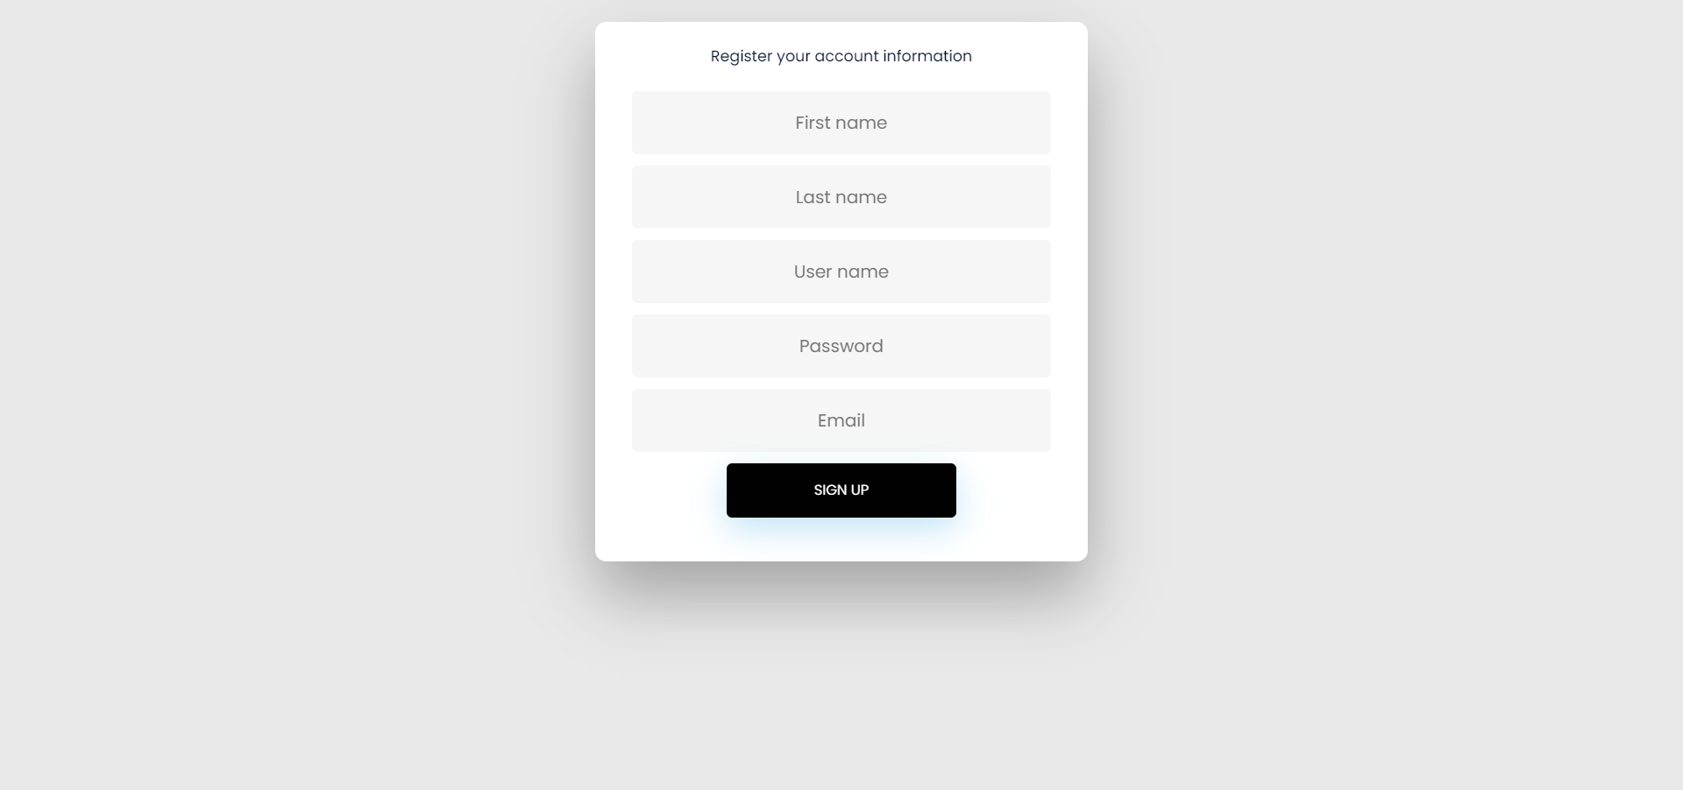

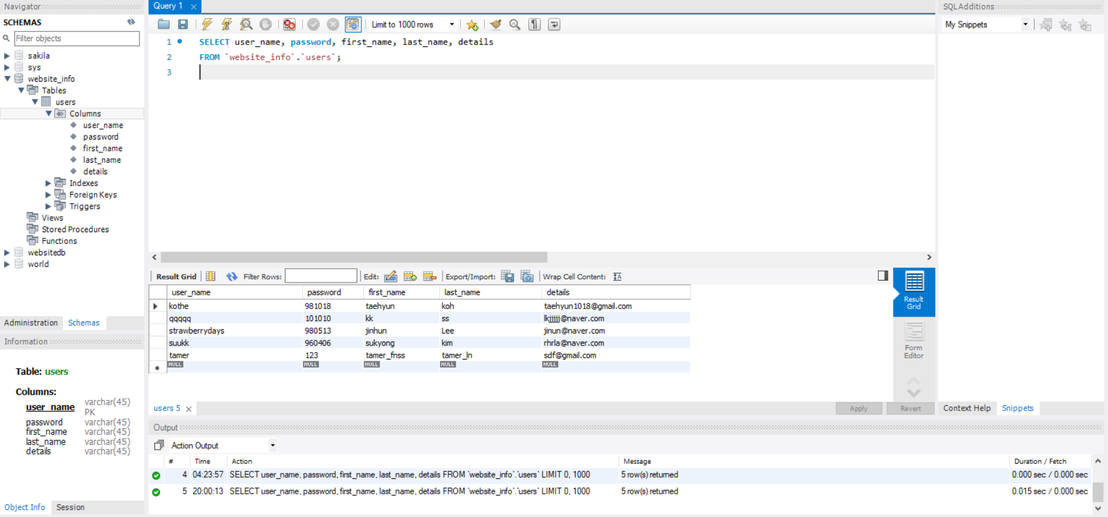

[Register page]

* In this register page, user registers as a member.
* The data entered by the user is stored in the DB as shown in the second image.
* User must register according to the DB tuple data form.



[Login page]

* This is the window where you log in based on the data user registered as a member.
* If the member information does not match, the jsp page breaks and login fails.
* If successful, you will be taken to the main page.

# Main page

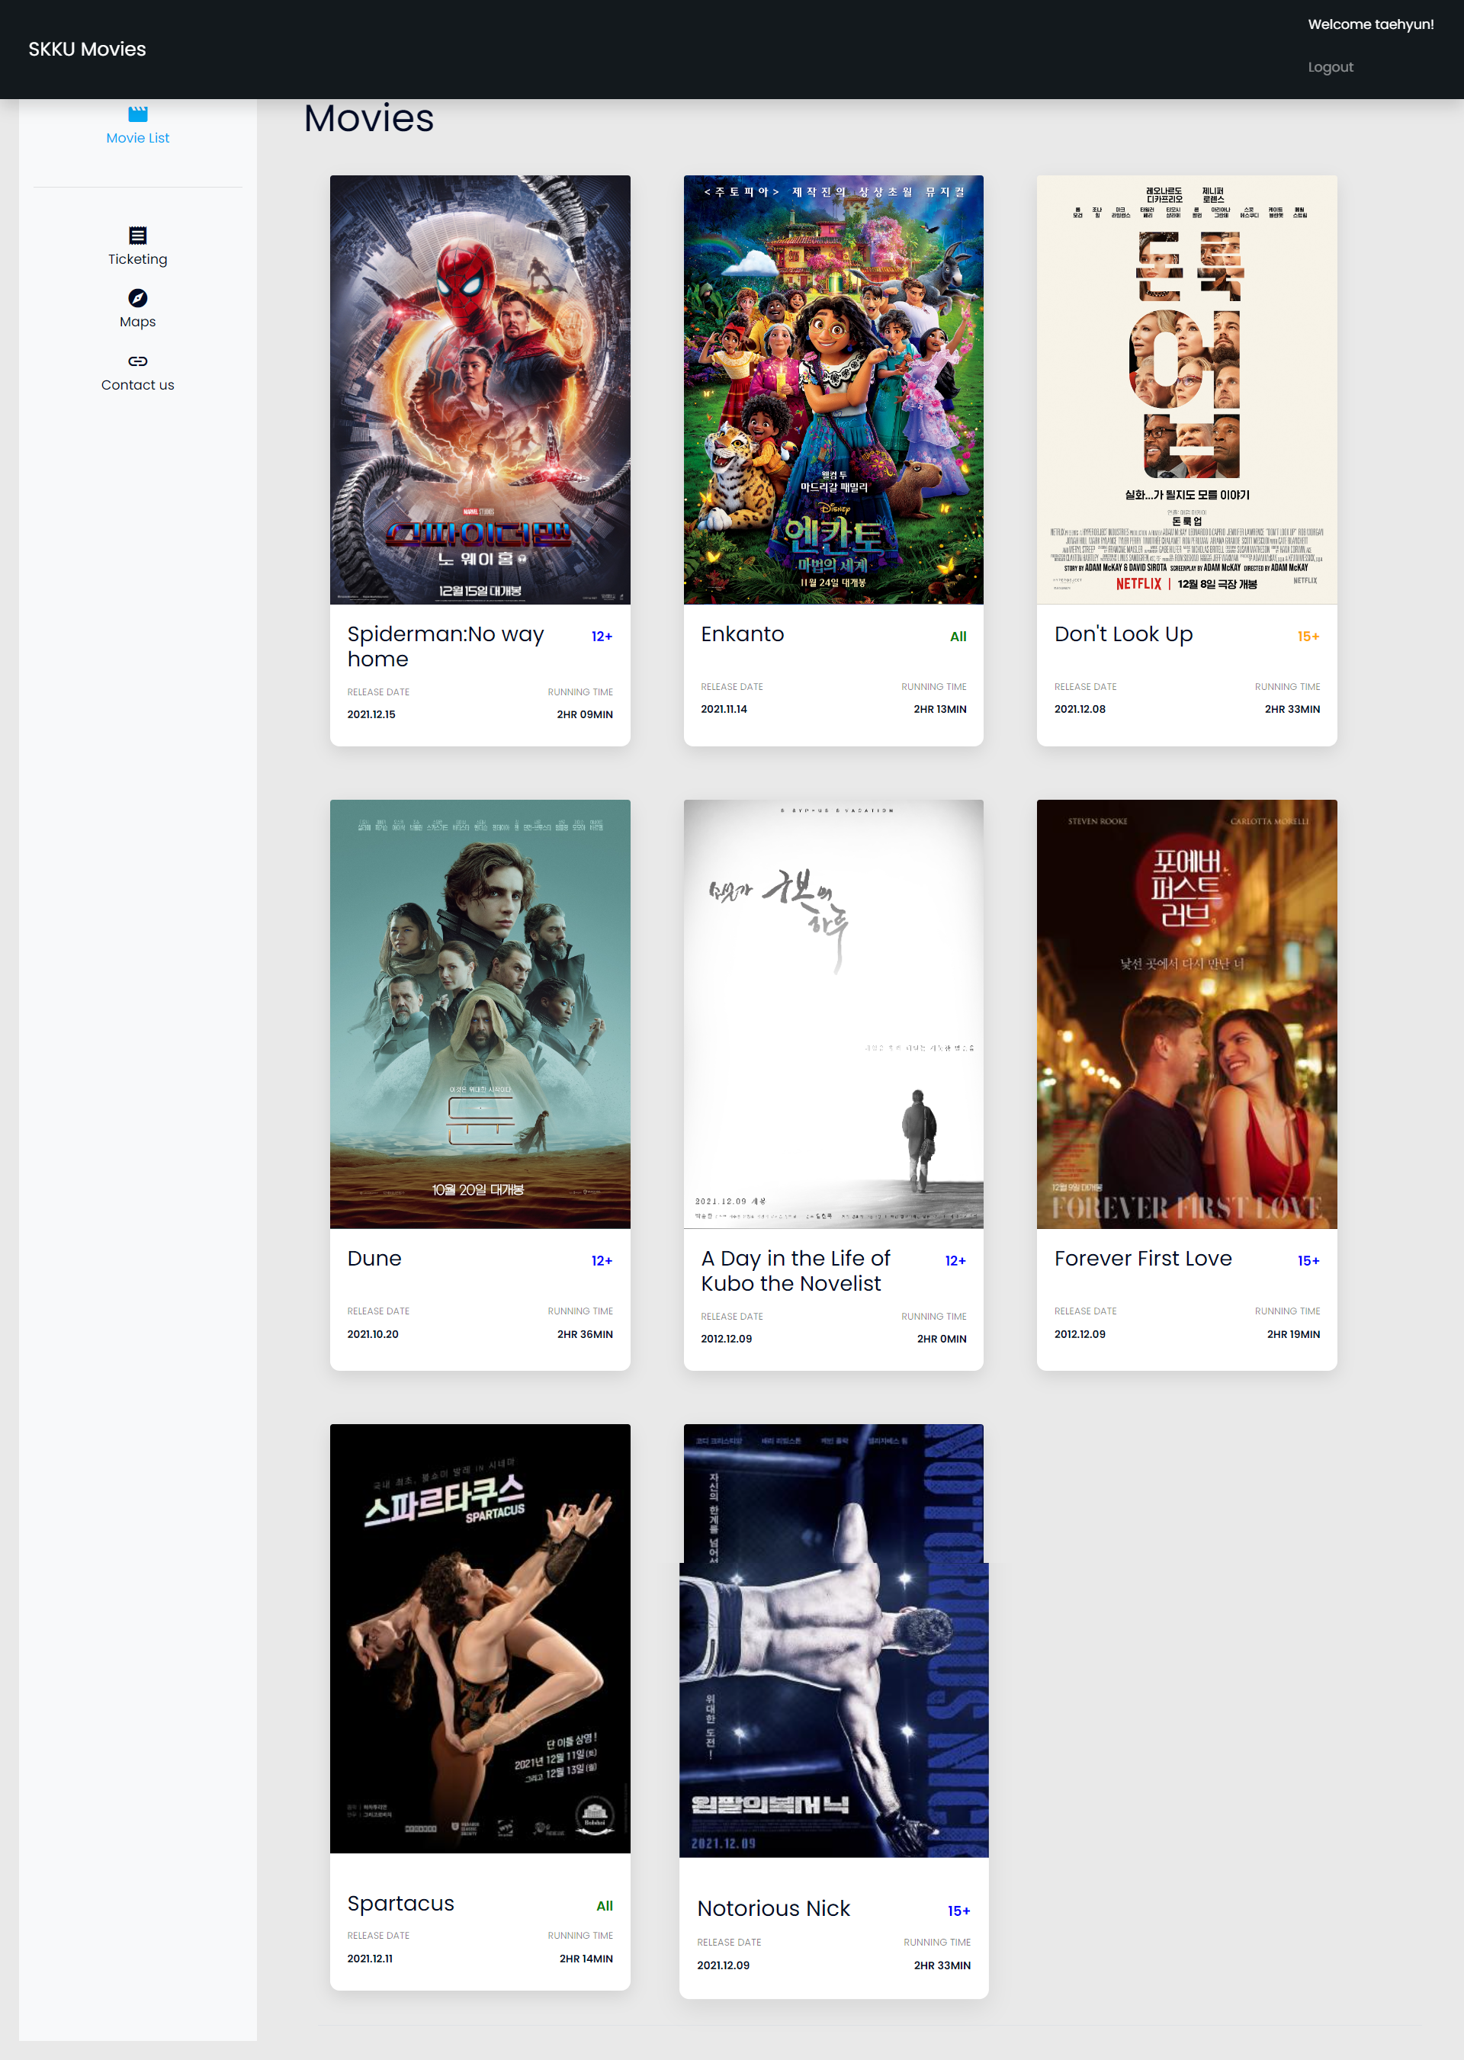

* This is the main page with information on the latest movies and functions based on these movies.

# Movie ticketing page.

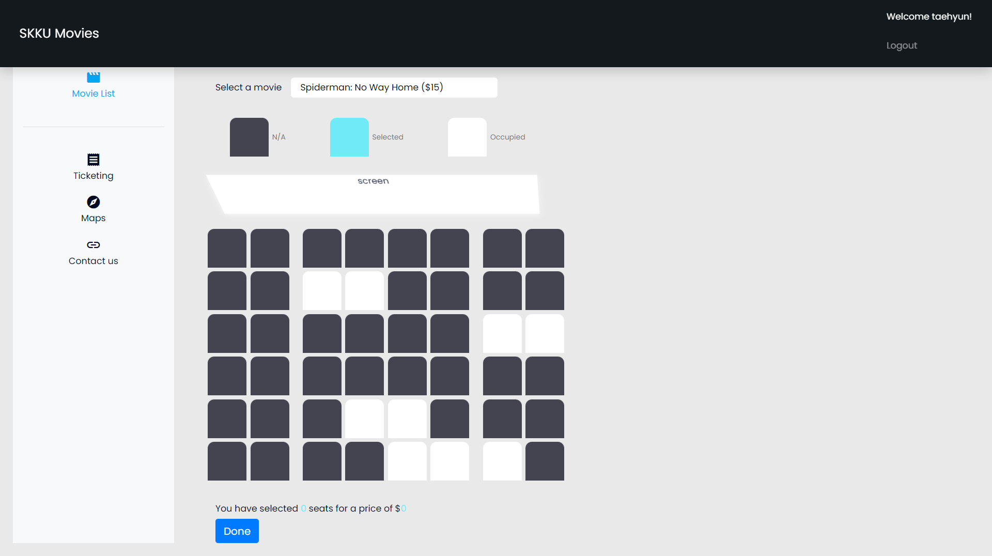

* If user click Ticketing menu on the side bar. User can select movie and click not occupied sit which is white color.
* If user pick one or many seat, js code calculate the number of selected seat and total price.

# Contact page

# 

- This is “Contact us” page on the side bar. There are info of website manager.

- User can send questions. When click send now, input data are stored at local storage.

# Map

## [Home Page]

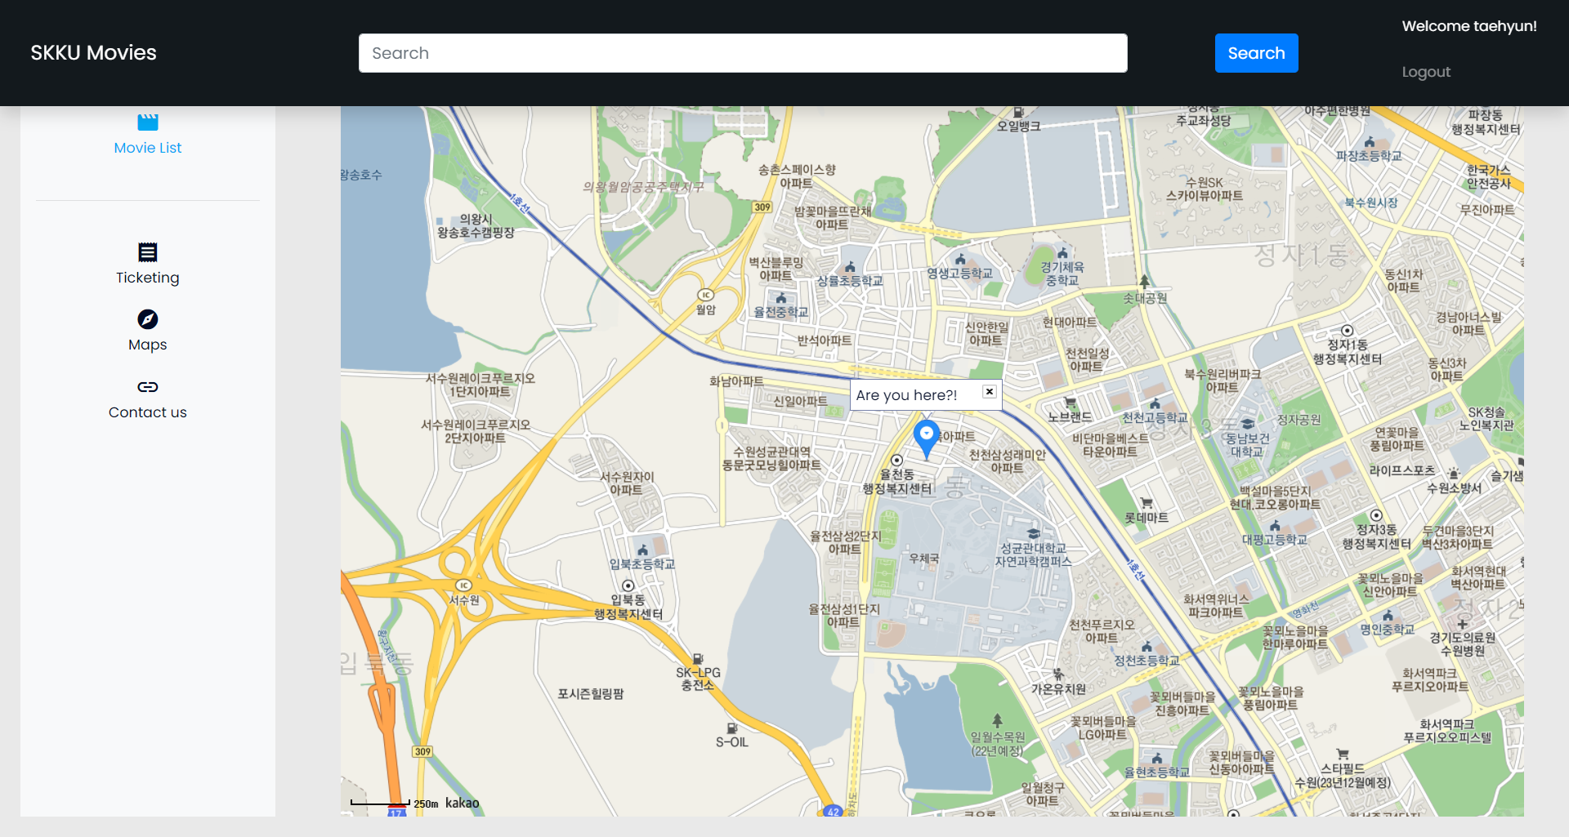

When user click maps menu on the side bar, website automatically get user’s location and display it on the map. This map is implemented by open API. With search input on the top, user can search movie theater.

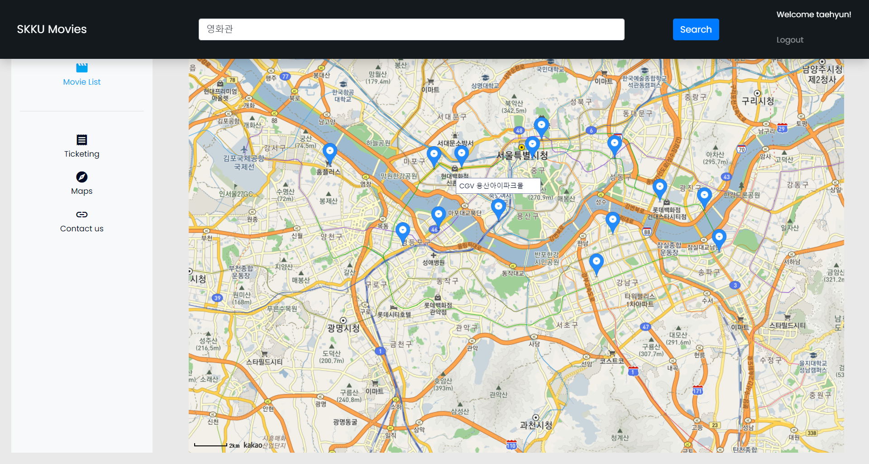

This is result of search. If user click the marker, name of location is shown. Through this function, user can decide where to see the movie. After that, users can also find out what to do in their spare time or what is around them. For example, If user decide to see movie at “용산아이파크몰”, search keyword “용산 카페”. Below is the result.

